Tile | Problem | Novelity | Journal | Year
Hey assistant, how can I become a donor?” The case of a conversational agent designed to engage people in blood donation | - insufficient knowledge and many misconceptions about the blood donation process  - everyday customer service had been receiving many calls and email messages with simple questions about the requirements and aspects of the blood donation process. These questions were often repetitive and had many details and complex specifications | Dialogflow framework to develop a conversational agent  - the user can interact freely and in any order by typing, speaking and selecting interface elements. The agent has multimodal support and always responds by displaying visual information. If the user interacts by speaking, the agent responds using speech synthesis technology with a male voice  (How they build it is absent in the paper)  (POV: They have strong User testing including sampling, Assessment frameworks, and data analysis by customers, They nicely portray user experience of their agent)  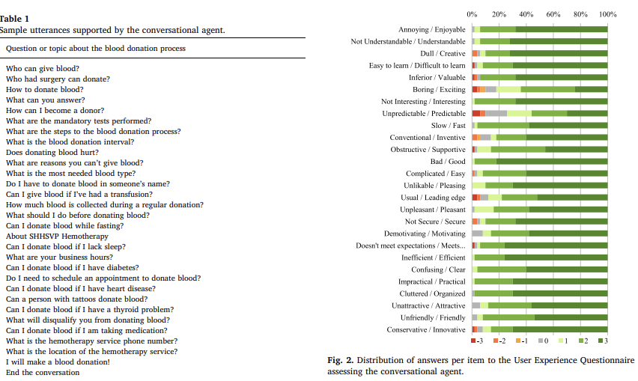 | Journal of Biomedical Informatics | 2020
Changebots - Designing Chatbots to Support Blood Donor Behaviour Change | How to design chatbots for potential blood donors to promote sustainable prosocial behaviour? | Detect Non-Donor, First time Donar, Lapsed Donar, regular Donar  chatbot on Google Dialogflow | 44th International Conference on Information Systems, Hyderabad, India 2023 | · November 2023
Investigating the Validity of Botometer-based Social Bot Studies | Botometer produces enormous amounts of false positives and that it should never be trusted without manual verification has been pointed out for years | Not related to our theme  But may need to write paper
Implementing all in One Platform to Optimize the Blood Donation Chain  (very relevant) | It takes a lot of time and work to retrieve blood, whether it's donor, receiver, or donation camp information. | - The blood donators will be registered to a system where they can be aware about the concerns of blood donating, and get notified in an emergency blood requirement, responding to the monthly blood requirements and aware about the nearby blood donations.  - The proposed system will filter them the best locations to organize blood donation campaigns and recommend the responsible resource holders within a short time  - Predicting the person's probability of donating blood and sending related notifications on blood donation (age, health)  - Predicting upcoming monthly blood requirement and encouraging people to donate blood according to the predicted requirements .Using Long Short-Term Memory (LSTM), Time series forecasting model can predict(they will use past info for prediction) | International Journal of Computer Application | November 2022
Does Culture Matter for the Design of Chatbots Promoting Blood Donation Behaviour? - The Difference in Perception of Culture-Tailored Conversation Styles | How does the culture-tailored conversation style of blood donation chatbots influence users’ intention to donate blood? | Not our theme | Forty-Fourth International Conference on Information Systems, Hyderabad 2023 | · November 2023
Summary:
Above papers focus on chatbots that will give necessary information about blood donation and increase the donar numbers
Previous Literature review of us:
The previous papers focus on systems building like web app development to make the whole supply chain.
Our Novelity:
We are not building any chatbot or web app as people need to use them by installing.
We will make bot which can be used in social medias (like whatsapp, Telegram, Facebook, Discord) as people now spend most of the time on social medias and share news regarding this. But the stories and posts are so messy, people miss them and no systemic way now exists for controlling those posts and stories.
There are big groups in existing.
Our bot can be used in these FB,WA,DC and Tg groups
-> filter messages which are about blood donation
-> send notifications to the nearest donors.

